**Taylor & Francis eBooks检索技巧**



**'Full Content Access Only' check box**

**“仅限全文访问”勾选框**

Check this box to only search content to which you have access. Leave the box unchecked to search all content.

勾选该选项，即可将检索限定在有全文访问权限的内容中进行。不勾选此选项则对全部内容进行检索。

**'Open Access Only' check box**

**“仅限开放获取内容”勾选框**

Check this box to view only our Open Access content.

勾选该选项即可查看我们的开放获取内容。

**Search by Subject**

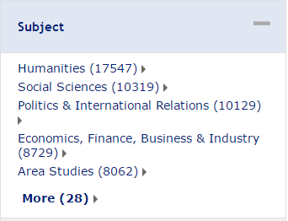**按学科检索**

Once you have entered your initial search term, you can refine your search by adding subject filters from within our subject taxonomy. There are four levels, structured to allow you to discover content in specific areas of interest.

输入了初始检索词后，可以根据我们的学科分类表添加学科筛选细化检索结果。学科分类分为4个级别，让您有条理的探索感兴趣的特定领域的内容。

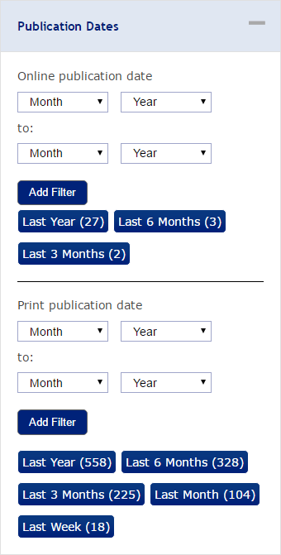**Search by Publication Dates**

**按出版日期检索**

该处提供了出版物在线出版日期和纸本出版日期2组时间段筛选框。可以根据不同需要进行筛选。

You are able to search by online/print publication date, entering two time periods (both MM/YYYY) to limit your search to within a specific date range.

根据在线/纸本出版日期搜索，设定2段时间（月/年）搜索在具体时间段之间出版的检索结果。

If you only enter a date in the top set of boxes, you will be presented with all content published since that date, and if you only enter a date in the bottom set of boxes, you will be presented with all content published up until the date you specify.

每组时间段选框中，若仅输入的起始日期（上面），将获得该日期之后出版的全部内容，若仅输入每组选框的截止日期（下面）则将获得该指定日期之前出版的全部内容。

NB: You need to select an additional search criterion, such as a keyword, when searching by publication dates. If you only enter dates, no results will be returned.

备注：当按出版日期检索时，您仍需选择其他的检索条件，如关键词。

**Search by Book Title**

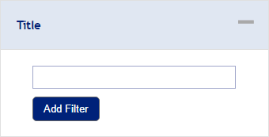**按书名检索**

Adding additional terms in this field will refine your search at the book title level. You have the option to enter a specific keyword, or part of a keyword alongside an asterisk, which will search for all other book titles containing that fragment.

在该检索框输入更多检索词将实现书目水平的精确检索。这里可以输入一个确切的关键词，也可以输入含有星号(*)的部分关键词来搜索包含该关键词变体的所有其他书目。

**Boolean Operators布尔运算符**

Within the search fields, the Boolean Operators AND (also + or &), OR, and NOT (also -) allow you to perform searches that specify logical relationships between terms. By default, i.e. if you do not use an operator, an AND-relationship between the terms you enter is established in the full text field.

在检索框中，运用布尔运算符AND（也作 +，&），OR，及 NOT（也作 -），可以指定检索词之间的逻辑关系来执行检索。不使用运算符的情况下，所输入的关键词之间在全文中都被默认为AND关系。

**Wildcards通配符**

Wildcards allow you to construct a query with approximate search terms. Use a question mark (?) in a search term to represent any one character and use an asterisk (*) to represent zero or more characters. There are two limitations of wildcards: You cannot use a wildcard at the beginning of a search term or in a phrase enclosed in quotation marks.

使用通配符，可以执行模糊检索条件的查询。可在检索条件中使用问号(?)代表任一字符，使用星号(*)代表任何一组字符（零或多个字符）。使用通配符有2个限制：不能在检索词开头使用通配符，也不能对引号中的短语使用通配符。

**Phrases短语/词组**

To search for documents containing an exact phrase, enclose the phrase in quotation marks. Phrase searches will not treat AND, OR, and NOT as Boolean Operators and will not strip out stop words.

若要搜索包含确切词组的文献，可在词组两边加引号。搜索词组中不适用于布尔运算符AND，OR，和NOT，而停止词也不会被忽略。

**Stop words停止词**

Stop words are such words as articles, pronouns, and other frequently used terms that don't normally add value to a search. These words are stripped out of a search query if they are not part of an exact phrase.

诸如冠词、代词、和连词这样的检索词，对检索来说通常没有什么意义。若这些停止词并非某个确切词组的组成部分，则将被忽略。

**Grouping分组**

To group subsets of terms, use parentheses around the terms you want to group. The search engine will evaluate terms within parentheses before evaluating the remaining terms.

可根据需要用括号来编组检索词。搜索引擎将优先评估括号中的检索词，然后评估其余的检索词。

**Stemming词干**

To enable stemming for a term, follow it with a hash mark (#).

在检索词后使用“#”来实现词干检索。

**Proximity位置算符**

To search for documents containing two or more terms within a certain distance of each other, put quotation marks around the terms followed by a tilde (~) and a number to indicate the maximum number of words apart the terms can be.

若要求搜索到的文献包含2个或多个相隔一定位置的词或词组时，在检索词或词组两边加引号，紧跟一个波浪号(~)并添加一个表示检索词或词组之间最大间隔单词数的数字。